**LAB TASK#1**

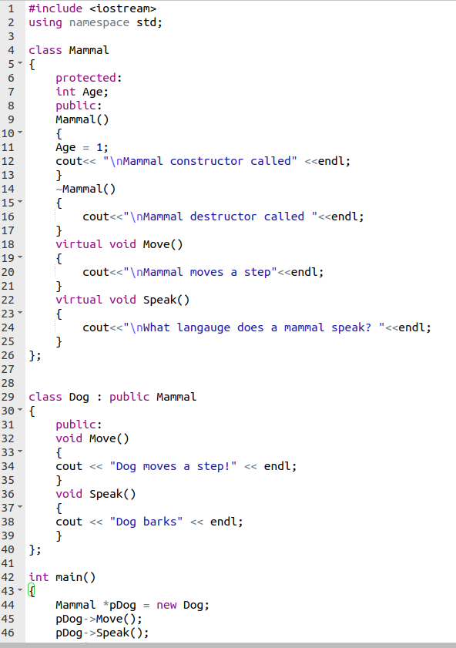

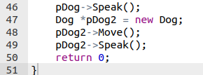

**OUTPUT**

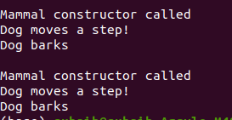

**LAB TASK#2**

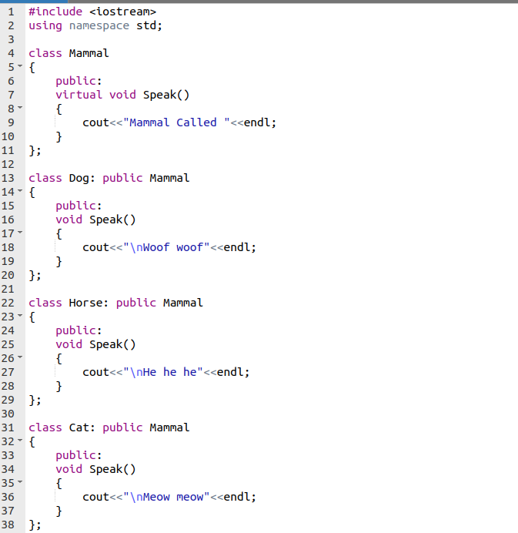

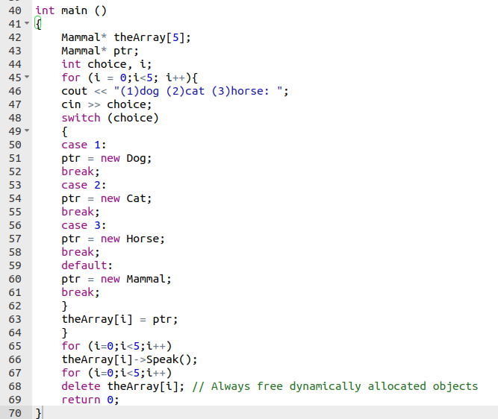

**OUTPUT**

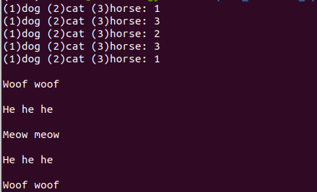

**Conclusion:**

In this lab I learned how to use polymorphism. I also learned how to use static, dynamic binding and the role of the virtual keyword in dynamic binding.